Layered architecture of spring boot

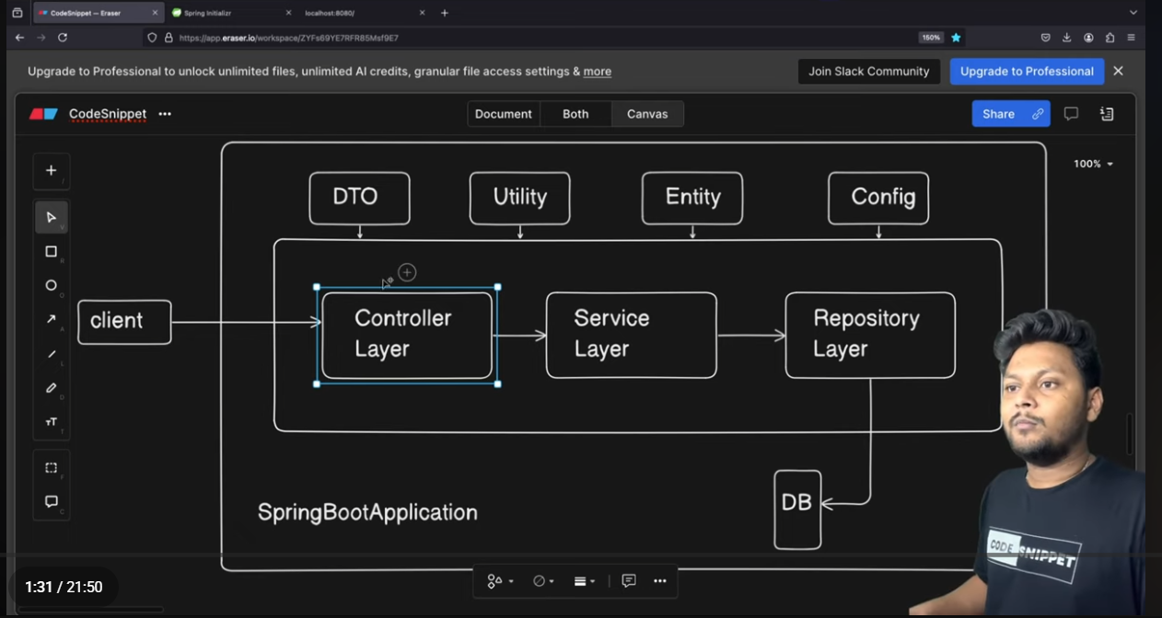
Controller , Service , Repository

- First client will make a request and controller will take request and send it to the service layer.
- Secondly the service layer wil handle all the businness logic and all .
- Thridly the service will tell the repository layer I need so and so from the database go and bring that to me .
- And then the repository layer is responsible for fetching and giving the data to the service layer and service layer do the logic and give the response to the controller and controller will take the reponse and give it to the client.

DTO
- Stands for data transfer object
- Purpose : used to transfer data between layers especially between client and server
- Why we use DTO:
- Avoid exposing entity directly
- Hide sensitive fileds (like password)
- Control request and response structure
- Reduce unnecessary data transfer
UTILITY
- Uitlity package contains helper classes
- Stores reusable common logic that does not belong to business layer
Ex : jwt token generatro , custom response handler …

Entity :
Entiry represents a database table
Used in spring data jpa / hibernate

Config :
Config stands for configuration
Used to define custom configuratinos in spring .

Ex : security configuration , cors configuration , bean configuration

